**LAB 4**

**AML**

**0**

Student Name: Joud Alahmari

Student ID: 2008071

Import data set

And do the splitting of data set and training set

Note:20% for testset,80% for training set

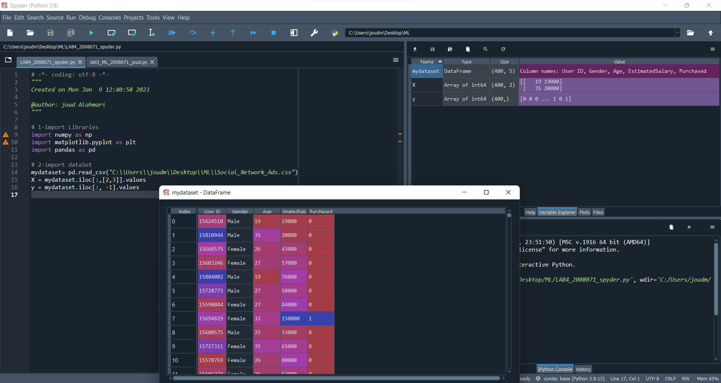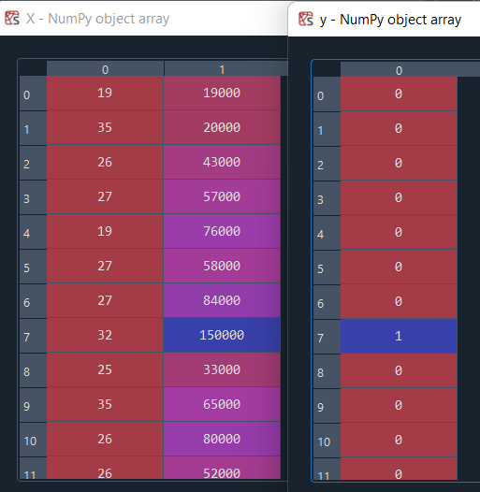

Training the Logistic Regression model on the Trainingset

And

predict the results

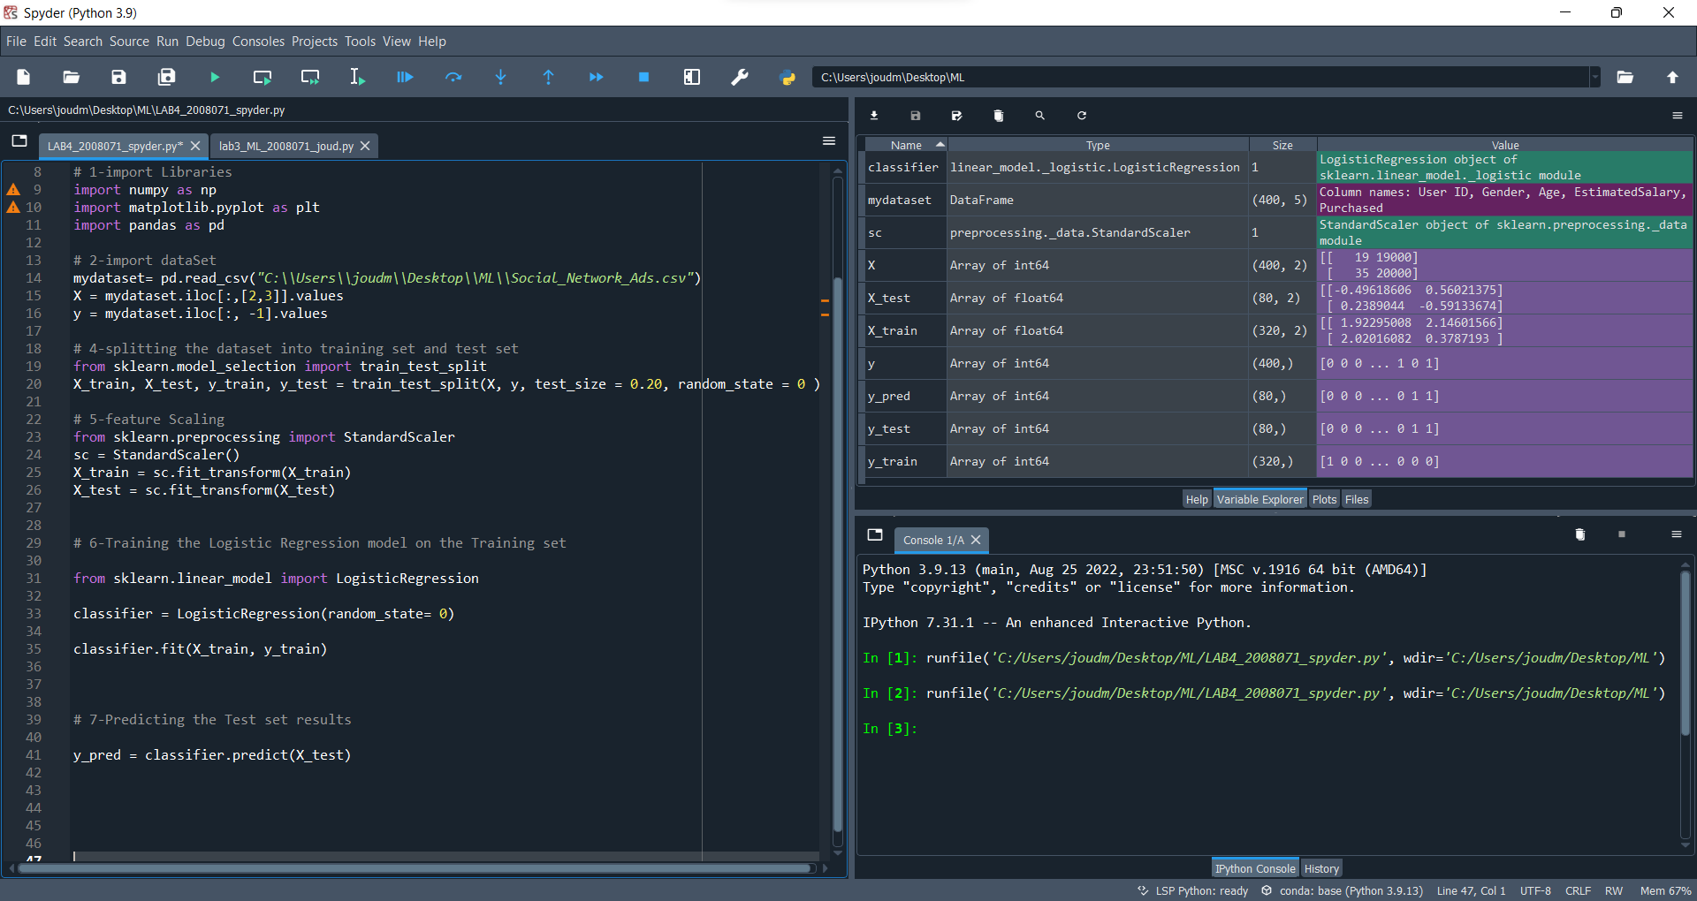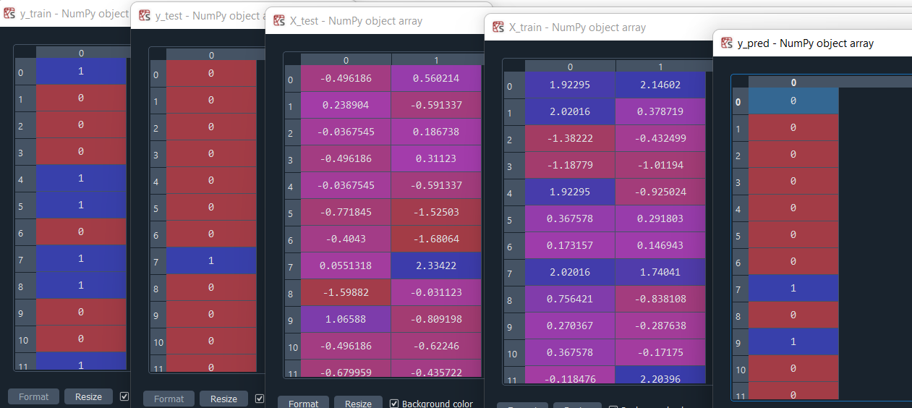

Visualising the Training set results

